Dylan Johnson

CSC 330

Final Project ReadMe

For this project I choose PowerShell as my language and built on the project that I submitted for Week 5’s assignment. I built out the program to be a bit more modular and make it easier to test. The point of this script is to keep the Chrome Driver on a given computer up to date for running web scrape automations, or any web automation. The program is set up to check a text file at a designated location for the last installed version of the Chrome Driver. If the versions are the same, it does nothing. If the saved number does not match the latest pull number, it will proceed to download the latest version, and save the file in a set location for use in other applications. Finally, it will save the newest version number to the text file mentioned above. This is set up to work on any PC it is set to run on so long as the files are in the same folder. Please see line 9 of “chromedriveupdate.ps1” if you are not using the default location for the save location of modules and update the “$fileSaveLocation” variable accordingly.

Included in this submission is 5 files, including the main file, a function file, and 3 test files. Below is a screenshot of the “chromedriverupdate.ps1”/main file, the “MyFunction.ps1” file and the test files. The main file pulls in the “MyFunction.ps1” file (Only function names in screenshot). The main file is only calling “Update-ChromeDriver” function, the rest are utilized within the function file itself. Finally, the 3 test files are included that are testing the 3 main functions: “Download-ChromeDriver”, “Get-LatestChromeVersion”, and “Get-CurrentChromeVersion”.

chromedriverupdate.ps1 File:

MyFunction.ps1 File

Test Files:

Output for each file:

chromedriverupdate.ps1 – If up to date:

-If updating to new version:

Download-ChromeDriver.Tests.ps1:

Get-LatestChromeVersion.Tests.ps1

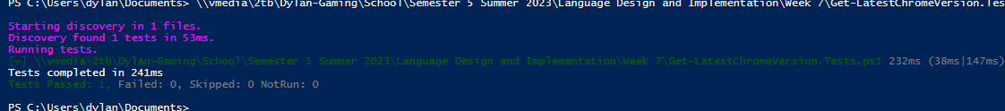

Get-CurrentInstallVersion.Tests.ps1

